
DOCUMENTATION

Certificate Of Completion:

GROUP MEMBERS :

Usman Ahmed -- (STD1422606)
Darakhshan -- (STD1420161)
Aiman Naseem -- (STD1361994)
Rayyan Ahmed -- (STD1362292)
Daniyal Arif -- (STD1361887)
Umair Ahmed -- (STD1403138)



PROJECT: Tourm Expense Voyage



Start Date:
18-September-2024

End Date:
21-September-2024

# | Table Of Content | No
1 | Problem Definition | 3
2 | Customer Specification | 4
3 | Project Plans | 5
4 | E-R Diagram | 6-7
5 | Algorithms | 8
6 | GUI Documents & Interface Design | 9-10
7 | Task Sheet | 11
8 | Project Review | 12
9 | Unit Testing Check List | 13
10 | Final Check List | 14

Problem Definition:

Traditional methods of tracking expenses, such as manual entry in spreadsheets or keeping physical receipts, are cumbersome and prone to errors. With the rise of digital transformation, there is a growing demand for automated solutions that simplify expense management. The proliferation of smartphones and easy Internet access provide an excellent opportunity to develop a Web application that addresses these challenges effectively.

Login Form

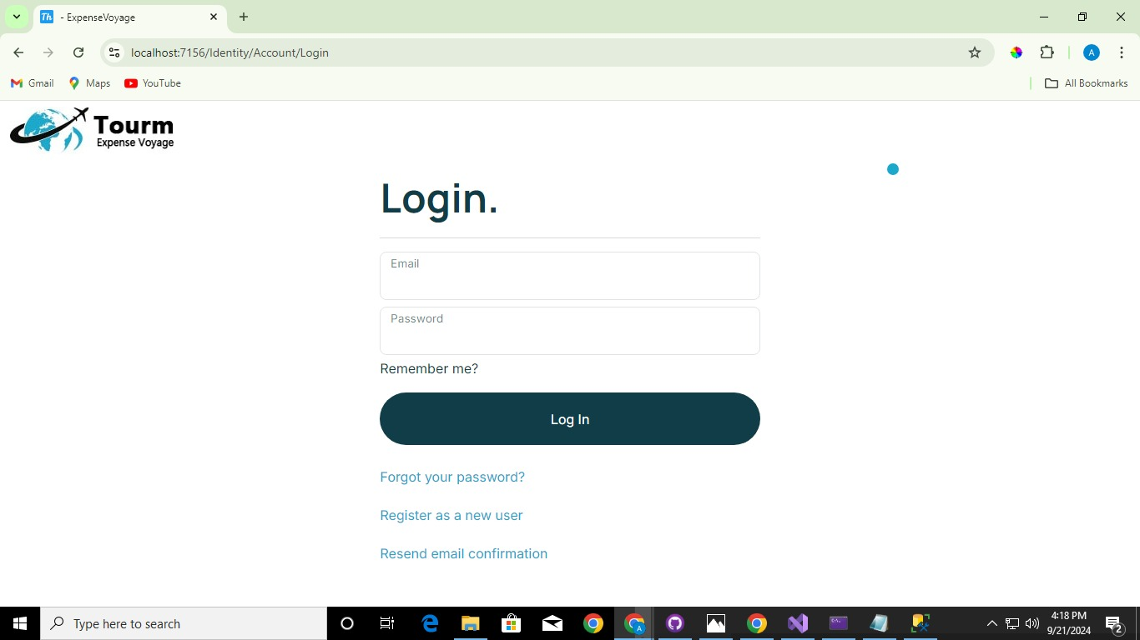

Customer Specification:
To make it easier for users, a Web application titled Expense Voyage is to be developed. This Web application will enable users to register, and thereafter facilitate efficient and user-friendly tracking of travel expenses and more. The application will cater to individual travelers as well as groups ensuring seamless and collaborative expense tracking.

Services & Check Delivery Details

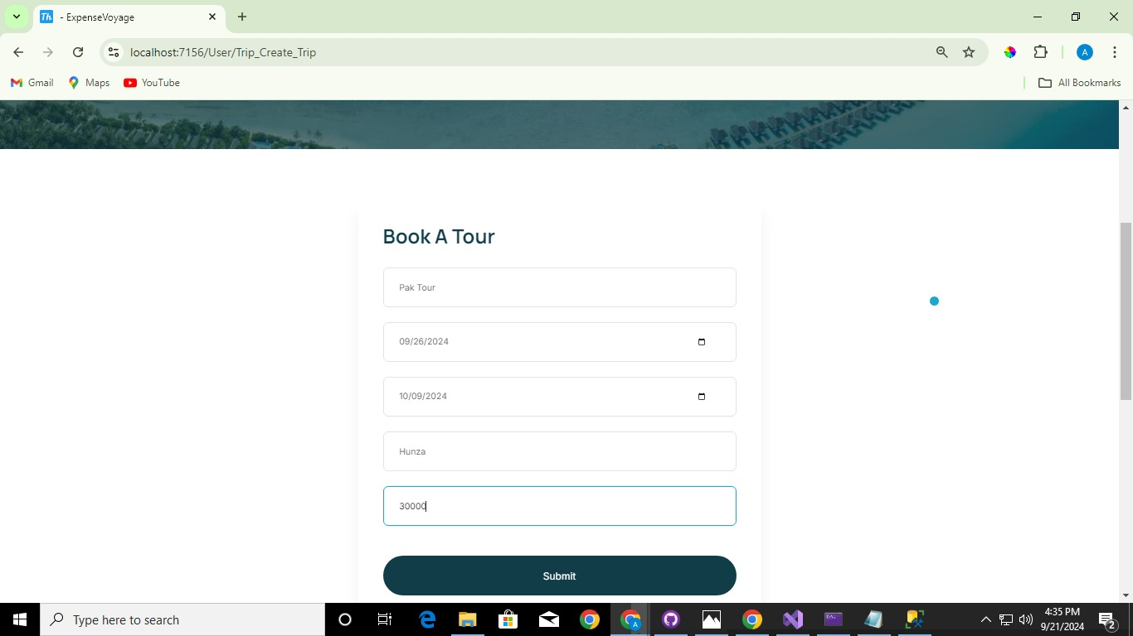

Project Plans:

Expense Voyage is an innovative platform designed to streamline the travel planning process, making it easier for users to budget, organize, and enjoy their trips. Whether you're planning a solo adventure, a family vacation, or a corporate retreat, Expense Voyage helps you manage every detail with ease.
With Expense Voyage, planning your next trip becomes an exciting and stress-free experience. Whether you’re a seasoned traveler or planning your first journey, our platform provides all the tools you need to make your trip memorable and well-organized. Start your adventure today with Expense Voyage!


E-R DIAGRAMS
Two type of E-R diagram us in Project
1) Without Relation
2) With Relation

Without Relation:

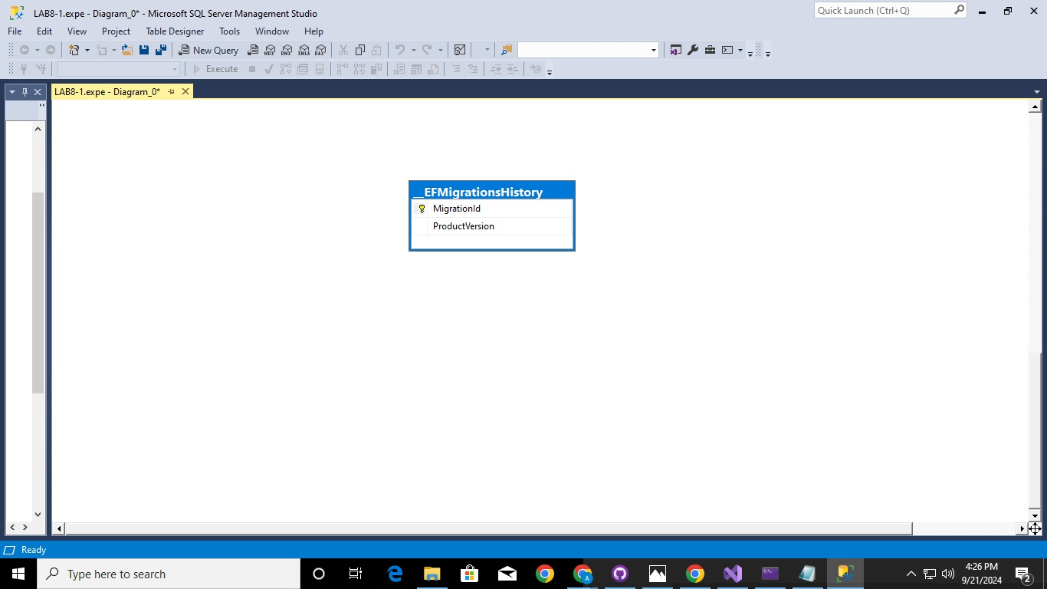
With Relation:

The database has been created with relationships, enhancing the program's speed and overall performance.

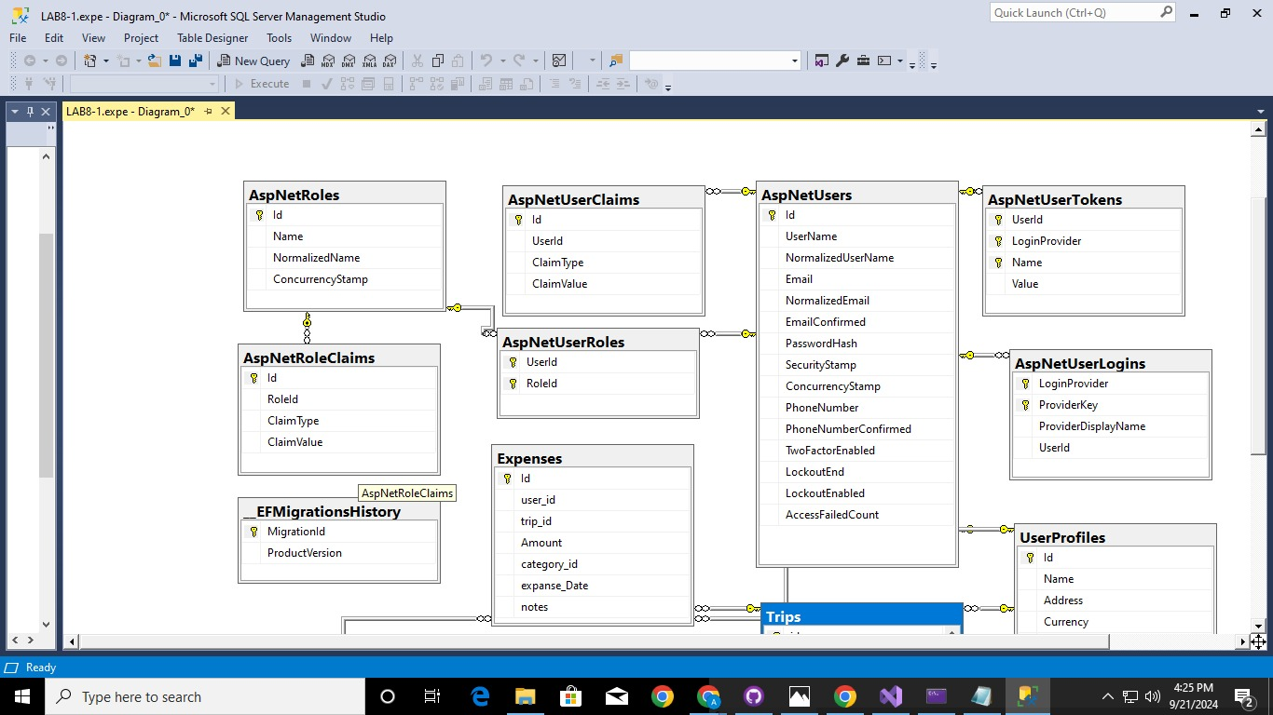

Algorithm:

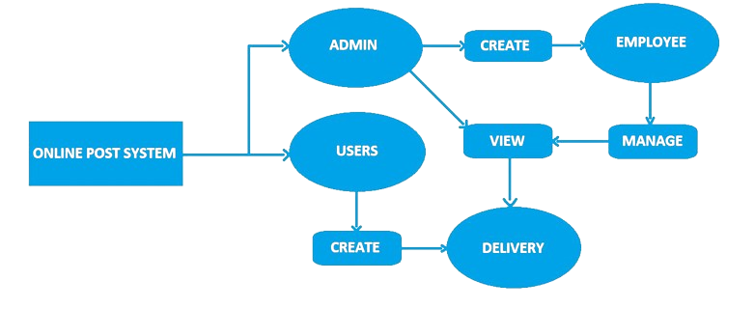
The project is outlined with an algorithm and flowchart, providing a concise description of its structure and processes.

User & Guest Theme:
GUI Document & Interface Design

The Expense Voyage platform features a personalized welcome message that greets users by name upon logging in, along with a visually appealing homepage that provides easy access to essential functionalities like registration and login. It showcases an overview of current and upcoming trips, including destination, dates, key itinerary items, and remaining budget, alongside a list of recent activities such as logged expenses and itinerary updates. Users can register with their email and password, manage their profiles, and upload profile pictures. They can create, edit, and delete trips, as well as manage itineraries with categorizable items like flights and accommodations. Real-time expense logging allows users to track spending, set overall and category-specific budgets, and receive alerts when nearing budget limits. The platform supports multiple currencies, providing exchange rates and enabling expense conversion to the user's preferred currency. Users can generate detailed expense reports and receive daily reminders and alerts for logging expenses and upcoming itinerary items, ensuring effective financial management and organization throughout their travels

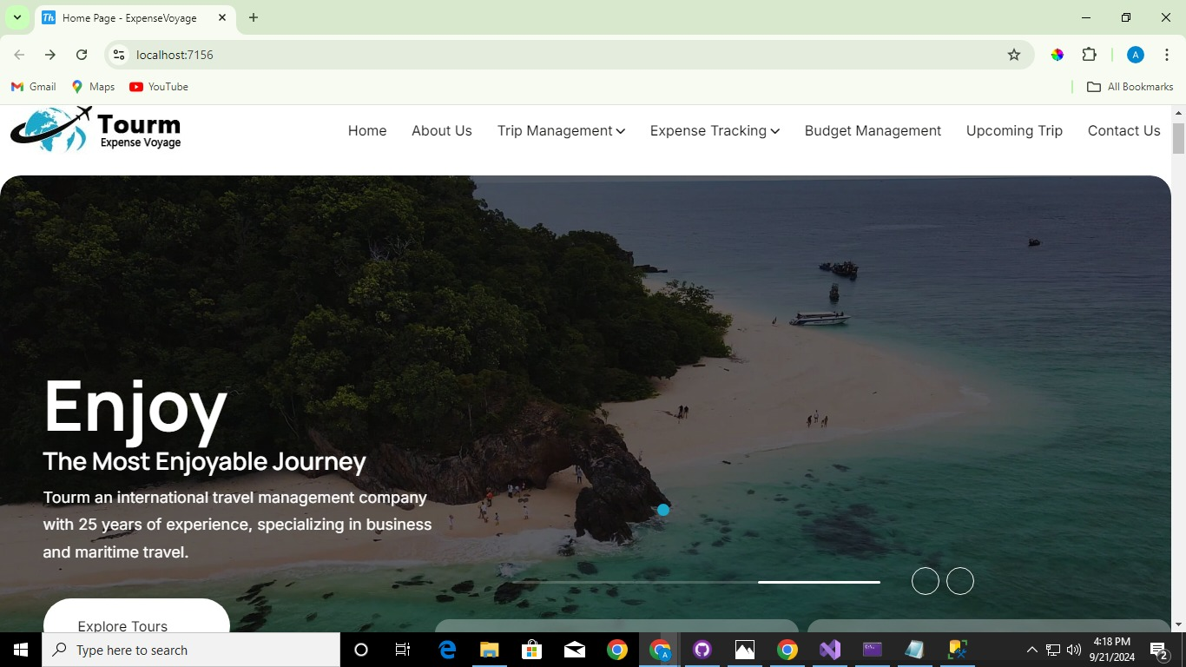

Task Sheet

Usman Ahmed (std1422606):

Role: Played a vital role in handling backend

Darakhshan (std1420161):

Role: Assisted in Models tasks and contributed to the presentation.

Aiman Naseem (std1361994):

Role: Responsible for generating all required content and managing frontend.

Daniyal Arif (std1361887):

Role: Contributed to the presentation and managed
Documentation.

Umair Ahmed (std1403138):
Role: Managed identities of the project and leaded the team
Rayyan Ahmed (std1362292):
Role: Handled most of the frontend



Project Review
&
Monitoring Report
The project review and monitoring report highlight the commendable performance of the project despite encountering challenges such as computer issues and complications with the ASP software. Despite these obstacles, with the help of Allah, the team successfully developed the project "Tourm Expense Voyage."



Unit Testing

In-depth testing has been conducted for every unit and component in the project, ensuring their robust functionality. The results indicate that each element performs exceptionally well. Moreover, each component brings a unique feature or functionality to the project, contributing to its overall versatility. This meticulous evaluation has played a crucial role in maintaining the high quality of the project.



Final Testing

Every component, feature, and requirement of the project has been meticulously addressed, ensuring their completion and satisfaction. Rigorous testing and verification procedures were implemented before the project's delivery to guarantee its quality and alignment with specified criteria. This thorough evaluation has fortified the project's overall reliability and performance. We are confident that the project is poised to meet or exceed expectations upon delivery.



Documentation End

